Work Insturction for 24171BBA02 Pultrusion Nozzle

Modified Item: Ender 3 compatible brass nozzle (6 mm hex nut, M6 thread, any nozzle diameter).

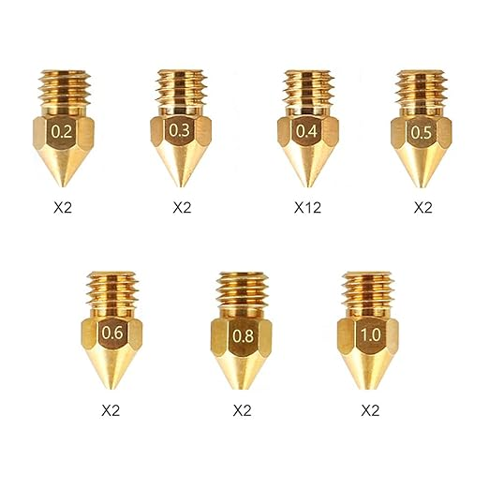
Equipment Required
- Drill press
- M6 hex socket
- 1.8? mm drill bit
- 1.7 mm drill bit
- 1/16” or 1 mm tapered router bit
- Old header block

- Install 1.8 drill bit in drill press
- Clamp hex socket onto drill press table
- Insert nozzle tip down into hex socket
- Center nozzle under 1.8 mm bit
- Replace bit with 1.7 mm bit
- Drill through nozzle
- Replace bit with tapered bit
- Taper hole as much as possible without damaging threads
- Remove nozzle and thread into heater block
- Clamp heater block into vice and file tip of nozzle flat
- Remove burrs with steel dwire brush

